21.45: a) At the origin, 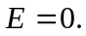
b) At 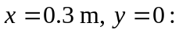

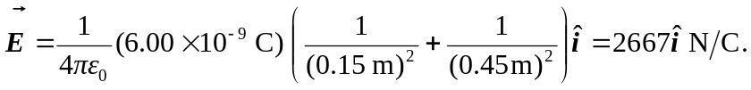

c) At 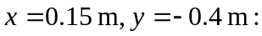

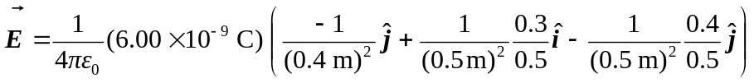
and 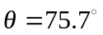 down from the x-axis.
d) 